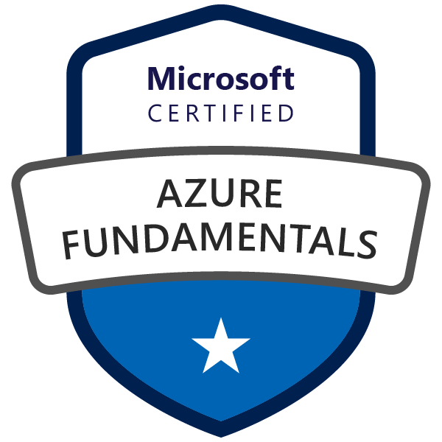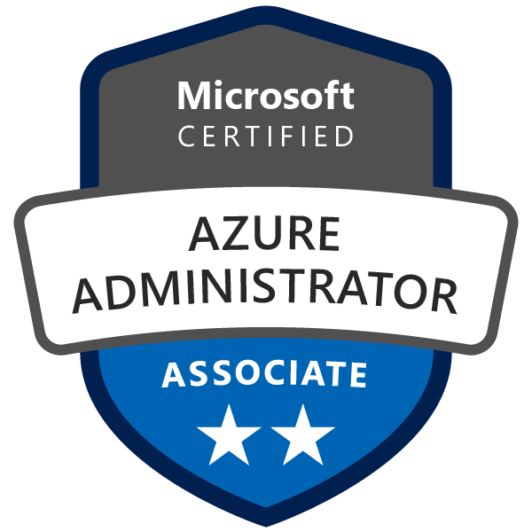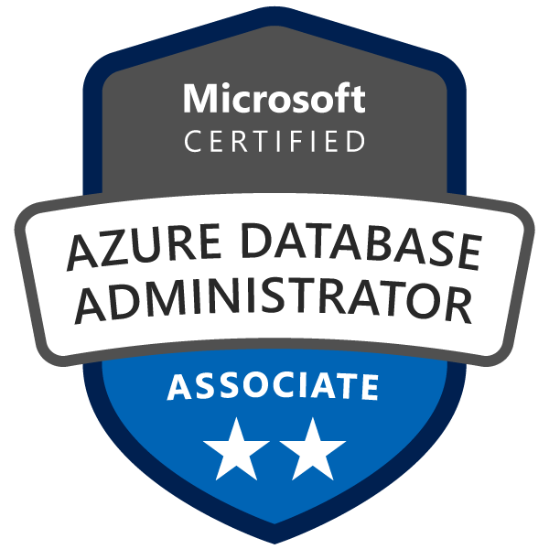

Bhanu Prakash M
Mobile: +919394000341
prakashdba308@gmail.com

Professional Summary

Over 10 years of experience in SQL Database Administration and 2 years in Azure SQL along with Postgresql and MongoDB knowledge. A beginner for Azure kubernetes (AKS).
Certifications:

- Microsoft Certified Azure Fundamentals – AZ900 (Certification Number H534-7250)
- Microsoft Certified Azure Administrator – AZ104 (Certification Number H583-2775)
- Microsoft Certified Azure Database Administrator Associate – DP-300 (Certification Number H608-7167)

SQL Azure

- Excellent knowledge and hands on experience in Migrations from on-premise to Azure IAAS and PAAS servers
- Having good experience into Geo-Replication, Availability Group(s) and Data Sync
- Troubleshoot Azure related issues and engage internal teams and vendor issue resolutions
- Create and configure Logical SQL servers, databases, elastic pools in Azure Cloud.
- Monitor performance and setup alerts to avoid performance issues occurring on Azure databases.
- Having hands on experience in Elastic Jobs and Run Books.
- Having good knowledge on External tables and Elastic pool Model(s)
- Import and Export data within Azure Cloud environment.
- Creating and Managing logins/Access levels in Azure IAAS and PAAS environments.
Installation

- Experienced in installation MS SQL Server 2016, 2012, 2008 R2 , 2008, 2005 and 2000 on stand alone and cluster servers.
- Expert in configuration of Microsoft Azure environment and also doing migration from data SQL machine to SQL Azure.

Upgrade and Migration

- Experienced in inplace upgrade and side by side upgrade and upgrade to new hard ware.
- Experienced in migration from lower version to higher versions and also to SQL Azure.
High availability and Disaster Recovery

- Implemented and supported Always On Availability Groups, Clustering, Database Mirroring, Logshipping, Replication.
- Experienced in creating Maintenance plans and backing up databases and restoring databases.
- Creating jobs and experienced in rebuilding master database and restoring Master database and user databases.
Contributions/Achievements to the Projects

- Expertise in grooming of Jun DBA’s by transferring the KT.
- Strong experience in mentoring team members and writing documentation.
Monitoring and performance Tuning

- Experienced in implementing the database mail, operator and implementing the alerts
- Monitor the production server using tools like SQL Profiler, Windows Performance Counters and SQL server logs for Monitoring and Tuning SQL Server.
Professional Experiences:

- Working as Sr. Database Administrator for “Optum, Hyderabad” from Dec, 2022 – Till Now
- Working as Sr. Database Administrator for “Accenture, Hyderabad” from June, 2021 – Dec,2022.
- Worked as Sr. Database Administrator for “WIPRO infotech, Hyderabad” from Oct, 2019 – June, 2021.
- Worked as Sr. Database Administrator for “VARA Infotech, Hyderabad” from Aug, 2016 – Sep, 2019.
- Worked as Sr. Database Administrator for “3i Infotech Ltd, Hyderabad” from Sep, 2014 – Jul, 2016.
- Worked as Jr. Database Administrator for “Systems Plus Solutions Pvt Ltd, Mumbai” from Dec,2012 – Sep,2014

Technical Skills:

SQL Server Tools | Management Studio, Azure Data Studio, Storage Explorer, BIDS, Profiler, Performance Monitor, Log Shipping, Database Tuning Wizard, SSIS, SSAS, SSRS and PSSDiag, PGAdmin, MongoAtlas.
Databases | SQL AZURE(IAAS, PAAS), MS SQL Server 2012,2008, 2005, 2000, PostgreSQL and MongoDB
Programming | TSQL, Basic knowledge on PowerShell
Operating Systems | Windows Server 2003, Windows2008, windows 2012, Linux
Domain Knowledge | Finance, Banking, Mobile , Marketing and Catering System
Other tools | Github, Jenkins

PROFESSIONAL EXPERIENCE:
Title: Azure DBA (Azure SQL as Primary and Azure PostgreSQL as Secondary)
Company: Optum
Duration: Dec 9, 2022 Till now
Team Size: 4

- Implementation of Hosting Azure SQL and Azure PostgreSQL services in azure IAAS and PAAS servers through Azure portal and Terraform.
- Create and configure Logical SQL servers, databases, elastic pools in Azure Cloud.
- Deploy builds on multiple databases in Azure cloud.
- Manually take the schema and data backups of the Azure SQL and Azure PostgreSQL databases and restore/copy databases and restore deleted databases in Azure cloud.
- Import and Export data within Azure Cloud environment.
- Creating and Managing logins/Access levels in Azure IAAS and PAAS environments.
- Migration of Azure SQL and Azure PostgreSQL databases from On premise to Azure Cloud environment.
- Setup maintenance plans for databases using Azure Elastic jobs and Azure automation methods.
- Setup Audit and threat detection logs to ensure the security of the databases in Azure cloud and recover any in case required.
- Monitor performance and setup alerts to avoid performance issues occurring on Azure databases.
- Troubleshooting issues occurred with the databases in Azure cloud environment.
- Enabling and Managing data masking and encryption in Azure cloud environment
- Enabling Geo replication to ensure availability of the Azure databases as DR plan.
- Enabling Long time retention backup policy for Azure databases.
- Monitor the health check of the SQL server and review and apply azure recommendations.
- Enable and manage query store for the azure sql databases.

PROFESSIONAL EXPERIENCE:
Title: SQL Server Azure DBA
Company: Accenture
Duration: June,2020 – Dec, 2022
Team Size: 4

- Implementation of Hosting SQL services in azure IAAS and PAAS servers.
- Create and configure Logical SQL servers, databases, elastic pools in Azure Cloud.
- Deploy builds on multiple databases in Azure cloud.
- Manually take the schema and data backups of the databases and restore/copy databases and restore deleted databases in Azure cloud.
- Import and Export data within Azure Cloud environment.
- Creating and Managing logins/Access levels in Azure IAAS and PAAS environments.
- Migration of databases from On premise to Azure Cloud environment.
- Setup maintenance plans for databases using Azure Elastic jobs and Azure automation methods.
- Setup Audit and threat detection logs to ensure the security of the databases in Azure cloud and recover any in case required.
- Monitor performance and setup alerts to avoid performance issues occurring on Azure databases.
- Troubleshooting issues occurred with the databases in Azure cloud environment.
- Enabling and Managing data masking and encryption in Azure cloud environment
- Enabling Geo replication to ensure availability of the Azure databases as DR plan.
- Enabling Long time retention backup policy for Azure databases.
- Monitor the health check of the SQL server and review and apply azure recommendations.
- Enable and manage query store for the azure sql databases.

Title: SQL Server Azure DBA
Company: Wipro
Duration: Oct,2019 – June, 2021
Team Size: 8

- Implementation of Hosting SQL services in azure IAAS and PAAS servers.
- Create and configure Logical SQL servers, databases, elastic pools in Azure Cloud.
- Deploy builds on multiple databases in Azure cloud.
- Manually take the schema and data backups of the databases and restore/copy databases and restore deleted databases in Azure cloud.
- Import and Export data within Azure Cloud environment.
- Creating and Managing logins/Access levels in Azure IAAS and PAAS environments.
- Migration of databases from On premise to Azure Cloud environment.
- Setup maintenance plans for databases using Azure Elastic jobs and Azure automation methods.
- Setup Audit and threat detection logs to ensure the security of the databases in Azure cloud and recover any in case required.
- Monitor performance and setup alerts to avoid performance issues occurring on Azure databases.
- Troubleshooting issues occurred with the databases in Azure cloud environment.
- Enabling and Managing data masking and encryption in Azure cloud environment
- Enabling Geo replication to ensure availability of the Azure databases as DR plan.
- Enabling Long time retention backup policy for Azure databases.
- Monitor the health check of the SQL server and review and apply azure recommendations.
- Enable and manage query store for the azure sql databases.

Title: Sr.SQL Server DBA
Company: Vara Infotech
Duration: Aug,2016 – Sep, 2019
Team Size: 32

- Installation, configuration and maintenance of MS SQL Server 2005,2008R2,2012,2014and 2016.
- Database Migration from Lower to Higher versions across all Prod, Dev and UAT environments.
- Implemented and maintained Always on Availability Group as Disaster Recovery solution on SQL Server 2014 and 2016.
- Implemented disaster recovery solution at the remote site for the production databases using Log Shipping and also maintained Clustering Setup as a DR.
- Applying patches and service packs to keep the database at current patch level.
- Rebuilding the indexes at regular intervals for better performance.
- Checking Database health by using DBCC commands and DMV’s.
- Worked on configuring Linked Servers to execute commands against OLE DB data sources on different servers.
- Created jobs for rebuilding of indexes and updating statistics.
- Installed and configured SQL Server Reporting Services (SSRS).
- Auditing of database for Worked on logins, user permissions and security in SQL server level and fixing orphaned users and worked on logins, user permissions and security in SQL server level.
- Checking the status of Backups and Restoration of Databases.
- Monitoring SQL server LOGS, Application logs (Event Viewer), Tuning SQL server databases using SQL Profiler, Performance monitor, database tuning advisor.
- Created and managed databases across Development and Production instances using SQL Server Management Studio.
- Plan capacity specification requirements for new database servers.
- Environment: Microsoft Windows 2012, 2008 and 2003 Server, Microsoft SQL Server 2005,2008 R2, Microsoft SQL Server 2012, 2014 and 2016.
- Additional Roles : Monitoring Drive spaces and Errors in Sql error log by using SCOM tool. Monitoring and closed tickets using HP SM tool, Scheduled Critical activities and Handover process.

Title: Sr.SQL Server DBA
Company: 3i Infotech
Duration: Sep, 2014 – Jul, 2016
Team Size: 32.

- Installation, configuration and maintenance of MS SQL Server 2005,2008R2,2012,2014and 2016.
- Database Migration from Lower to Higher versions across all Prod, Dev and UAT environments.
- Implemented and maintained Always on Availability Group as Disaster Recovery solution on SQL Server 2014 and 2016.
- Implemented disaster recovery solution at the remote site for the production databases using Log Shipping and also maintained Clustering Setup as a DR.
- Applying patches and service packs to keep the database at current patch level.
- Rebuilding the indexes at regular intervals for better performance.
- Checking Database health by using DBCC commands and DMV’s.
- Worked on configuring Linked Servers to execute commands against OLE DB data sources on different servers.
- Created jobs for rebuilding of indexes and updating statistics.
- Installed and configured SQL Server Reporting Services (SSRS).
- Auditing of database for Worked on logins, user permissions and security in SQL server level and fixing orphaned users and worked on logins, user permissions and security in SQL server level.
- Checking the status of Backups and Restoration of Databases.
- Monitoring SQL server LOGS, Application logs (Event Viewer), Tuning SQL server databases using SQL Profiler, Performance monitor, database tuning advisor.
- Created and managed databases across Development and Production instances using SQL Server Management Studio.
- Plan capacity specification requirements for new database servers.
- Environment: Microsoft Windows 2012, 2008 and 2003 Server, Microsoft SQL Server 2005,2008 R2, Microsoft SQL Server 2012, 2014 and 2016.
- Additional Roles : Monitoring Drive spaces and Errors in Sql error log by using SCOM tool. Monitoring and closed tickets using HP SM tool, Scheduled Critical activities and Handover process.

Title: Jr.SQL Server DBA
Company: Systems Plus Solutions Pvt Ltd
Duration: Dec,2012 – Sep,2014
Team Size: 2

- Creating and maintaining various databases on production/development servers and provide 24 x7 support.
- Implementing database development enhancements to multiple SQL Server databases to ensure a flawless functioning of production environment.
- Monitoring database status, logs, space utilization, extents, Checkpoints, locks and long transactions.
- Planning and applying latest Service Packs and patches to different versions of SQL Server.
- Management of users including creation/alteration, grant of system/dB roles and permissions on various database objects.
- Analyzing long running slow queries and tune the same to optimize application and system performance.
- Responsible and Involved in SQL Server Performance Monitoring, Server and Database optimization and tuning & used Windows Perform and various 3rd party tools to monitor SQL Server health and gauge the performance.
- Verify, maintain & troubleshoot database backups, error logs, integrity checks.
- Scheduling Jobs and Alerts using SQL Server Agent Implementation of log shipping for disaster recovery.
Designing and implementing the comprehensive Backup plan and disaster recovery strategies.

Education:

Graduation : Bachelor of Technology (Mech.) – DVRCET, Hyderabad
Post Graduation : MBA (Finance&Marketing) – Sai Krishna Collage, Wanaparthy

Strengths:

- Excellent Communication skills to present point precisely and clearly.
- Good problem solving ability and analytic skill to solve problem efficiently.
- Good team player and have excellent interaction skill to coordinate and work with the team.
- Excellent Technical skill.

Personal:
Languages : English, Hindi, Telugu.

